<http://www.army.mod.uk/royalengineers/26485.aspx>

**History**

The Royal Engineers built Mulberry Harbour, prefabricated in Britain and towed across the Channel on D-Day to provide logistic support for the Allied invasion force.  
  
The Royal Engineers, or Sappers as they are known, have blazed a trail of innovation and achievement through history. The term Sappers originates from the trenches or 'saps' which engineers were employed to build towards enemy positions to allow the placing and detonating of explosive charges.  
  
Originally called Sappers and Miners, the name Sappers has stuck with the Royal Engineers throughout their history.  
From the earliest developments in military aviation, signaling and and tank warfare to the very latest bridging systems and map making techniques, the Sappers have operated at the cutting edge of technology and frequently in the most inhospitable conditions.  
  
That commitment to ingenuity and the problem solving of practical problems is as strong today as it has ever been and the Sappers continue to fulfil an essential role all over the world.  
  
**A Brief History of the Royal Engineers**In its 900-year history the Royal Engineers has been involved in every major conflict the British Army has fought, as well as carrying out humanitarian roles such as providing clean water and building schools.  
  
The Corps of of Royal Engineers has a long heritage that not many corps can rival - it can claim direct descent from the military engineers that William the Conqueror brought to England. Since then it has lived up to its Motto 'Ubique' ('Everywhere'), having had a significant presence at every large-scale battle the British Army has ever fought.  
  
**New Technology**  
Early Tank DevelopmentThe Royal Engineers have introduced new technology to the British Army throughout their history including diving, telegraphy and the development of the tank.  
  
**Corps formed from the Royal Engineers**Many new Corps and organisations have been formed from the origins of the Royal Engineers including:  
  
1912 - Royal Flying Corps, later the Royal Air Force (RAF)  
  
The Royal Engineers' interest in aeronautics began in the 1860's when they explored the possibilities of using air balloons for aerial observation purposes. This interest developed into an interest in fixed winged aircraft. In 1912 the Royal Flying Corps, the fore runner of the Royal Air Force (RAF), was formed from the Royal Engineers.  
  
1920 - Royal Corps of Signals (from the Telegraph and Signal Service)  
  
The Royal Engineers interest in military communications began during the Crimean War (1854-56), when they were given an opportunity to use telegraph equipment. In the 1860's the Royal Engineers developed a system of flag and lamp signaling for use on military campaigns. By the end the First World War the Royal Engineers (Signal Service) had so developed and expanded that it was decided that it should become a corps in its own right - the Corps of Royal Signals formed in 1920.  
  
**Other Organisations that originated with the Royal Engineers**  
Ordnance Survey Survey, began in 1747, was the first of the Royal Engineers 'specialist' activities. Between 1820's-1856 soldiers of the Corps of Royal Sappers and Miners assisted officers of the Corps of Royal Engineers in survey duties in the British Isles and elsewhere in the British Empire. Today's Ordnance Survey was developed from the early Royal Engineers survey activities.  
  
Royal Navy Divers  
  
RE Divers 1902 Diving as one of the Corps 'specialist' activities was introduced in 1838 by Colonel (later General Sir) Charles Pasley (1780-1861). In the early days both Royal Engineers and Royal Sappers and Miners trained as deep water divers. Shallow water diving capabilities were developed in the 1950's. The Sappers taught the first Royal Navy divers.  
  
**Sporting Achievements**How many British Army units and Corps can claim to have won the FA Cup? The Royal Engineers can!

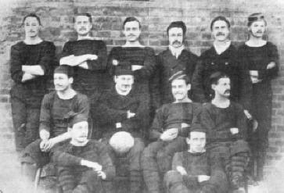**The Sappers win the FA Cup** (Picture right): The Royal Engineers won the FA Cup at the Kennington Oval, London, on 16 March 1875. They were also runners up in 1872, 1874 and 1878. Read the Cup Final Statistics on www.thefa.com website that shows when the Royal Engineers won the FA Cup.

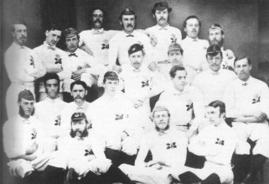**1871 Scotland versus England rugby union match** (Picture bottom): Two Royal Engineers, Lt C W Sherrard RE and Lt C A Crompton RE, both members of Blackheath RFC, became the first soldiers to gain the distinction of playing Rugby for their country ( England ) in the first ever international game. The Scotland v England match was played at Raeburn Place in Edinburgh on 27 March 1871 in front of a crowd of 4,000. Scotland won by one goal and one try to one goal, the teams were 20-a-side and Halves were 50 minutes each! The following year in 1872 they were followed by Lt F T Maxwell RE and Lt H W Renny Tailyour RE, who were capped for Scotland. Of note, Lt Renny Tailyour also played cricket and football and was a member of the Sapper Football team that won the FA Cup in 1875.

**Royal Engineer Museum**900 years of history cannot be condensed into just a few pages. If you would like to delve deeper into the history of the Royal Engineers you should visit the RE Museum in Kent. The museum achieved Designated status in 1998 and is one of only 43 Museums in the country to have achieved this certification.  
  
**Institution of Royal Engineers (InstRE) website.**The history of the Corps is currently contained in eleven volumes, with Volume 12 covering the years 1980-2000 due to be published in early 2008.  
  
The Institution of Royal Engineers has painstakingly converted each volume of the Royal Engineers history archive into electronic documents, available for you to view and search on a new CD-ROM. The CD ROM is available to purchase on their website.  
  
The Corps History could fill numerous books. Several books are available to purchase from the Institution of Royal Engineers (InstRE).

## [21 Engr Regt - Ripon, N Yorks](http://www.army.mod.uk/royalengineers/units/28642.aspx)

Location of 21 Engr Regt

## [22 Engr Regt - Tidworth, Hampshire](http://www.army.mod.uk/royalengineers/units/28643.aspx)

Location of 22 Engr Regt

## [23 Para Engr Regt - Woodbridge, Suffolk](http://www.army.mod.uk/royalengineers/units/28644.aspx)

Location of 23 (Air Assault) Engr Regt

## [24 (CDO) Engr Regt - Barnstaple, N Devon](http://www.army.mod.uk/royalengineers/units/28645.aspx)

Location of 24 (CDO) Engr Regt

## [26 Engr Regt - Tidworth, Hampshire](http://www.army.mod.uk/royalengineers/units/28646.aspx)

Location of 26 Engr Regt

## [32 Engr Regt - Hohne, Germany](http://www.army.mod.uk/royalengineers/units/28648.aspx)

Location of 32 Engr Regt

## [33 (EOD) Engr Regt - Wimbish, Essex](http://www.army.mod.uk/royalengineers/units/28649.aspx)

Location of 33 (EOD) Engr Regt

## [35 Engr Regt - Paderborn, Germany](http://www.army.mod.uk/royalengineers/units/28650.aspx)

Location of 35 Engr Regt

## [36 Engr Regt - Maidstone, Kent](http://www.army.mod.uk/royalengineers/units/28651.aspx)

Location of 36 Engr Regt

## [39 (Air Sp) Engr Regt - Kinloss, Moray](http://www.army.mod.uk/royalengineers/units/28653.aspx)

Location of 39 (Air Sp) Engr Regt

## [42 (Geo) Engr Regt - Huntingdon, Cambridgeshire](http://www.army.mod.uk/royalengineers/units/28654.aspx)

Location of 42 (Geo) Engr Regt

## [101 (EOD) Engr Regt - Wimbish, Essex](http://www.army.mod.uk/royalengineers/units/28655.aspx)

Location of 101 (EOD) Engr Regt

## [20 Works Gp RE (Air Support)](http://www.army.mod.uk/royalengineers/units/35495.aspx)

Location of 20 Works Gp RE (Air Support)

## [170 (Infra Sp) Engr Gp - Chilwell, Nottingham](http://www.army.mod.uk/royalengineers/units/28733.aspx)

Location of 170 (Infra Sp) Engr Gp

## [Royal Monmouth RE - Monmouth, Wales](http://www.army.mod.uk/royalengineers/units/28725.aspx)

Location of Royal Monmouth RE

## [71 Engr Regt - St Andrews, Fife](http://www.army.mod.uk/royalengineers/units/28726.aspx)

Location of 71 Engr Regt

## [75 Engr Regt - Warrington, Cheshire](http://www.army.mod.uk/royalengineers/units/28729.aspx)

Location of 75 Engr Regt

## [131 Independent Commando Squadron - London, Plymouth, Birmingham & Bath](http://www.army.mod.uk/royalengineers/units/28730.aspx)

Location of 131 Indep Cdo Sqn

## [135 Geo Sqn - Ewell, Surrey](http://www.army.mod.uk/royalengineers/units/28731.aspx)

Location of 135 Geo Sqn

## [299 (Para) Sqn RE - Wakefield, West Yorkshire](http://www.army.mod.uk/royalengineers/units/28734.aspx)

Location of 299 (Para) Sqn RE

## [591 Indep Fd Sqn - Bangor, Northern Ireland](http://www.army.mod.uk/royalengineers/units/28732.aspx)

Location of 591 Indep Fd Sqn

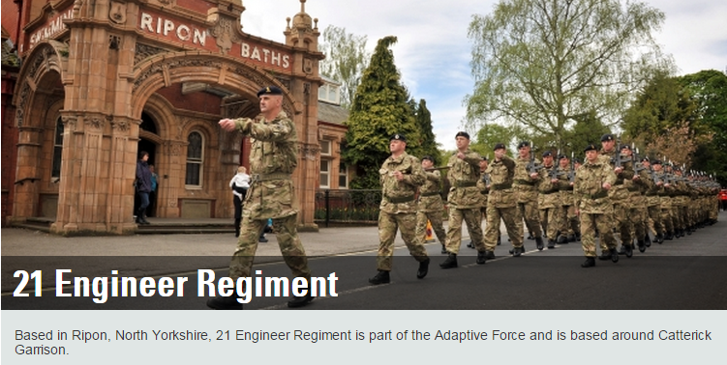

The Regiment consists of the following sub units all of which have their own ethos and traditions:

• 7 Headquarters and Support Squadron  
• 1 Field Squadron  
• 4 Field Squadron  
• 103 Field Squadron  
• 106 Field Squadron  
• Royal Electrical and Mechanical Engineers Light Aid Detachment

Each Engineer Squadron provides close support to the units within the Adaptive Force, allowing them to live, move and fight within their area of operations. More specialised capabilities are also held in the Headquarters and Support Squadron, such as a Reconnaissance Troop, Construction Design Cell, Divers, plant vehicles, and Automotive Bridge Launching Equipment (ABLE) for General Support Bridging (GSB).

Now that the Regiment is part of the Army 2020 Adaptable Force it has taken under command two Army Reserve sub units: 103 Field Squadron (located in Newcastle) and 106 Field Squadron (located in Sheffield).

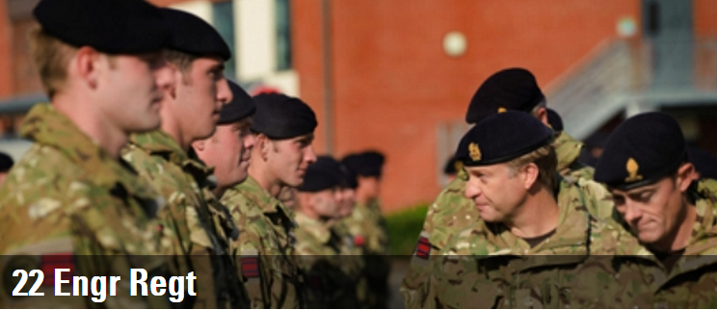

Based at Swinton Barracks in Perham Down, near Tidworth, 22 Engineer Regiment provides Engineer Close Support to 1 Mechanized Brigade.  
  
The Regiment consists of the following units:

6 Headquarters and Support Squadron.  
3 Armoured Engineer Squadron.  
5 Armoured Engineer Squadron.  
52 Armoured Engineer Squadron.  
Royal Electrical and Mechanical Engineers Light Aid Detachment.

**Capabilities**

Each Armoured Engineer Squadron provides close engineer support to the battle groups within 1 Mechanised Brigade, predominantly with the TITAN bridge layer and the TROJAN Armoured Engineer vehicles and Combat Engineer sections.  
  
This capability enables the battle groups to move, live and fight within their area of operations. More specialised capabilities are held in the Headquarters and Support Squadron, such as Reconnaissance, construction design and survey, diving, plant and Automotive Bridge Launching Equipment for the General Support Bridge.  
  
**Deployments**

In 2012, 22 Engineer Regiment will deploy on exercise to Kenya in support of the 2nd Battalion Royal Regiment of Scotland and twice to Canada in support of the 2nd Royal Tank Regiment battle group and the 1st Battalion Royal Regiment of Fusiliers battle group. These exercises are part of the Regiment's preparations for a deployment to Afghanistan in support of 1 Mechanised Brigade in 2013.  
  
All the Armoured Engineer Squadrons deployed to Afghanistan in 2011, working across the Helmand province in support of ISAF in a number of different roles which included route proving and clearance, working as part of the Counter-Improvised Explosive Device Task Force, as part of Armoured Support Groups as well as providing intimate engineer support to infantry patrols and utilisng their artisan skills to build, upgrade and maintain Forward Operating Bases to enable the combat elements to live and fight.  
  
6 Headquarters and Support Squadron also deployed on a construction tour to Cyprus in the last 3 months of 2011 to build a reception centre for troops that transit through Cyprus on their return home from operations in Afghanistan. They managed to combine this with a diving exercise to allow members of the Regiment's diving team to practice their skills.  
  
**Sport, Adventure Training and other opportunities**

The Regiment has a good sporting ethos, with teams regularly competing in rugby, football, boxing, golf, cross country, swimming and volleyball. Members of the Regiment have been successful at representing the Army in football, rugby, power lifting and martial arts. Of particular note, the Regiment has had a very successful boxing season so far, making it to the Army semi-finals.  
  
A large contingent from the Regiment spent the end of January and the beginning of February 2012 on a Regimental Alpine Skiing Exercise in Tignes. The Regiment also managed to field a team in the grueling sport of Nordic and Biathlon Skiing between November 2011 to February 2012, with members going on to compete in the Army Championships in Germany. Closer to home, adventurous training activates have been conducted in Snowdonia and Brecon Beacons, in Wales. The Regiment has also taken part in offshore sailing in the English Channel.  
  
As part of the further education of the officers and soldiers within the Regiment, battlefield studies of the Second World War have been undertaken in Normandy and Slovakia.



23 Parachute Engineer Regiment provides, close and general engineer support to 16 Air Assault Brigade. The Regiment is held at a very high state of readiness and regularly called upon to deploy on operations across the globe. Insertion can be by parachute, helicopter or fixed wing aircraft.

Based in its flagship barracks (Rock Barracks) just outside Woodbridge in Suffolk, the Regiment consists of 2 Regular parachute squadrons and a Reserve parachute squadron, all of which are air assault capable.

Arduous training conditions the Regiment's soldiers for the challenges of operations. Much is asked of every member of the Regiment and in turn they are all highly valued for the roles they play.

With an overall strength of 543 personnel, 375 of which are to be filled with parachute trained personnel. There is therefore always a need for volunteers to attempt ‘P’ Company and go on to become an Airborne Sappers.

**Airborne Engineer Reserve**

The Regiment includes 299 Parachute Squadron Royal Engineers, a Reserve unit who are based across the North West of England providing close and general engineer support to 23 Parachute Engineer Regiment, the dedicated Regular Army Engineer unit in 16 Air Assault Brigade.  
In order to carry out this highly specialist role, the Squadron needs well trained, physically and mentally robust soldiers who are capable of passing the famous parachute forces selection course ‘Pegasus Company’ (P Coy).

Upon successful completion of 'P’ Coy, soldiers are eligible to attend the Basic Parachute Course and qualify to wear the parachute wings and the coveted maroon beret of the British Airborne Forces.  
  
For more information please visit [299 Para Sqn RE](http://www.army.mod.uk/royalengineers/units/28734.aspx) page or ring 01904668332

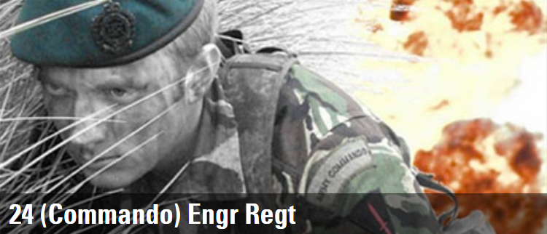

24 Commando Engineer Regiment supports 3 Commando Brigade Royal Marines. Expeditionary in nature, this elite fighting force is optimised as an Amphibious formation, with the unique ability to rapidly deploy around the World and project force without reliance on ports or airfields.

Based in Chivenor, North Devon, 24 Commando Engineer Regiment is required to conduct operations across the spectrum of conflict in support of 3 Commando Brigade, meaning that each member must be trained in amphibious warfare, as well as know how to operate; in the jungle, across deserts, over mountainous terrain and in arctic conditions.  
  
The Regiment currently has an establishment of 361 Officers and Soldiers and is formed into 2 Squadrons; 54 Commando Headquarters and Support Squadron RE and 59 Commando Squadron RE. The Full Operational Capability of 24 Commando Engineer Regiment will only be achieved with the formation of 56 Commando Squadron RE; hopefully in the near future.  
  
**The Coveted Green Beret**  
The coveted Green Beret, the distinctive hallmark of Commando trained troops, is worn by the Regiment, recognising those who have completed the grueling and physically demanding tests of endurance, whilst displaying the Commando spirit.  
  
**Joining the Regiment**All individuals who volunteer to join the Regiment will have the opportunity to complete the 9 week All Arms Commando Course, after receiving coaching to develop their strength and endurance. Progressive in nature, this pre-course Conditioning package focuses upon developing the individual to undertake the arduous activities of the Commando course. The "train-in" not "select-out" ethos of the course, providing the individual with the best chance of success.

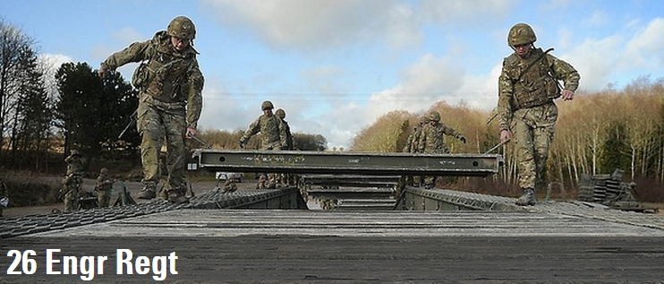

26 Engineer Regiment is an Armoured Engineer Regiment that provides close engineer support to 12 Mechanised Brigade.  
  
The Regiment is located in Swinton Barracks Perham Down, a site it shares with 22 Engineer Regiment. The Barracks has seen significant investment the Regiment benefits from new purpose built working and living accommodation.  
  
The Regiment consists of 4 Squadrons, 38 Headquarters and Support Squadron, 8 Armoured Engineer Squadron (AES), 30 AES, 33 AES and has its own REME Light Aid Detachment (LAD). Having been stood down from Op TELIC 14 at the start of 2009, the Regiment prepared for Exercise WARPAINT, a construction exercise at the British Army Training Unit Suffield (BATUS) in Canada. During this deployment the Regiment updated the training area, giving it a more current operational feel. Also at this time 33 AES deployed on Op HERRICK 10 and participated in Op PANTHERS CLAW, the Brigade clearance of Babaji.  
  
While in Canada, 8 AES were stood up to deploy on Op HERRICK 11 for Op BAM, the updating of forward operating bases throughout Afghanistan. 30 AES were also stood up at short notice to deploy an armoured troop to Helmand Province, to clear routes in support of Op MOSHTARAK. This deployment would see the first operational usage of the TROJAN engineer vehicle and the PYTHON mine clearing system.

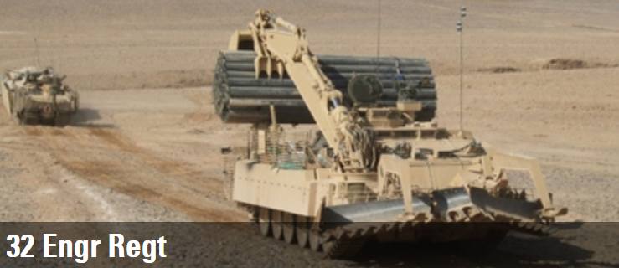

32 Engineer Regiment supports 7th Armoured Brigade - 'The Desert Rats'. With its adaptable yet robust make up the Regiment is capable of a wide variety of tasks.  
  
Whether providing conventional close support to an armoured battle group using the state of the art Titan and Trojan armoured vehicles; delivering dismounted close support to light role troops on operations; or undertaking general and force support engineering in peace time and on operations; 32 Engineer Regiment has the capability.  
  
Based in Hohne, North Germany, 32 Engineer Regiment derives its heritage from the engineer tank units, christened 'Hobart's Funnies' after their creator Major General Sir Percy Hobart, that proved vital to the Commonwealth Sectors during the D Day Landings. As a result the Regiment wears the Bull's Head insignia on its uniform.  
  
With an establishment of 644 Officers and Soldiers, 32 Engineer Regiment is formed into 4 squadrons: 2 HQ & Support Squadron, 26 Armoured Engineer Squadron, 31 Armoured Engineer Squadron and 39 Armoured Engineer Squadron.

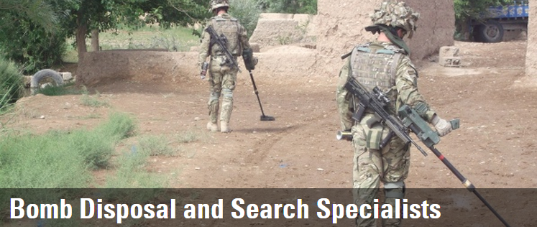

33 Engineer Regiment (Explosive Ordnance Disposal) was born out of the Royal Engineers’ Bomb Disposal companies formed during the Second World War, to deal with the mounting problem of German unexploded bombs. After the war these clearance companies were disbanded and responsibility for UK EOD was shared between the Territorial Army (now the Army Reserve) and the Regular Army, predominantly HQ (BD) Unit UK Royal Engineers.

Formed in 1973, 33 Engineer Regiment (EOD) took over responsibility for UK EOD and is now one of two specialist Explosive Ordinance Disposal and specialist Advanced Search Regiments for the Corps of Royal Engineers. As such the Regiment is heavily committed to enduring operations in Afghanistan where its primary role is the finding and clearing of IED’s (Improvised Explosive Devices).

The Regiment also maintains a significant commitment to UK Military Aid to the Civil Power (UK MACP) and has the responsibility for Explosive Ordinance Clearance (EOC) both in the UK via the EOC Group and overseas.

33 Engineer Regiment (EOD) is a Hybrid unit, meaning that it contains both Reserve and Regular Army components. The Regiment comprises of the following sub-units:

• 58 Field Squadron (EOD)  
• 821 Field Squadron (EOD)  
• 217 Field Squadron (EOD)  
• 350 (Sherwood Foresters) Field Squadron (EOD)  
• EOC Group

The Regiment is predominantly based at Carver Barracks, Saffron Walden with their sister Regiment 101 (City of London) Engineer Regiment (EOD). Our two Reserve units are 217 Fd Sqn (EOD), and 350 (Sherwood Foresters) Fd Sqn (EOD). Both units are fully integrated with their Regular colleagues deploying on training exercises both nationally and abroad as well as regularly providing augmentees on Operations.

**The Reserve squadron details are below:**

217 Field Squadron (Explosive Ordnance Disposal)

Gordon Road

Ilford

IG1 1SW

Tel: 02084777718

Email: [33engr-217-SSM@mod.uk](mailto:33engr-217-SSM@mod.uk)

350 (Sherwood Foresters) Field Squadron (Explosive Ordnance Disposal)

Foresters House

Swiney Way

Chilwell

Nottingham

NG9 6GX

Tel: 0115 9464909 (Ext 5217)

Email: [33engr-350-wo-rrmt@mod.uk](mailto:33engr-350-wo-rrmt@mod.uk)

Despite its many tasks the Regiment is committed to providing an active sports and adventure training program for all its soldiers. The Regiment also maintains a pool of Parachute, Commando and Dive trained personnel to enable EOD and Search support to all areas of the Armed Forces.

33 Engineer Regiment (EOD) forms part of 29 EOD and Search Group along with 101 (City of London) Engineer Regiment (EOD), 11 EOD Regiment RLC and 1 Military Working Dogs Regiment.

If you are interested in joining the Regiment as part of the Army Reserve, please contact the ROSO on 01223 203608.

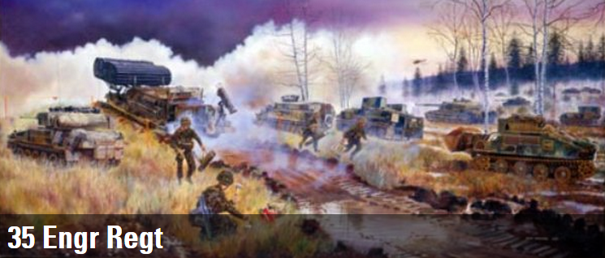

35 Engineer Regiment are part of 1 (UK) Armoured Division and supports 20 Armoured Brigade. The Regiment is located in the Cathedral city of Paderborn, Germany. and resides in Barker Barracks along with the 1st Battalion Princess of Wales Royal Regiment (1 PWRR) and 3 Battalion Royal Electrical and Mechanical Engineers (REME).  
  
The Regiment consists of 3 Armoured Engineer Squadrons, a Headquarters and Support Squadron, a REME Light Aid Detachment (LAD).  
  
44 Headquarter Squadron.  
29 Armoured Engineer Squadron.  
37 Armoured Engineer Squadron.  
77 Armoured Engineer Squadron.

The Regiment moved to Paderborn from Gordon Barracks in Hameln in 1999.

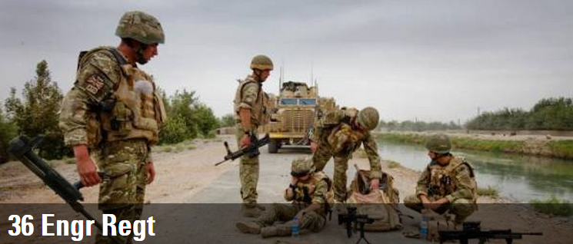

36 Engineer Regiment is a General Support Engineer Regiment, which is part of 3 (UK) Division. The Regiment is based in Maidstone at Invicta Park Barracks. The Regiment consists of a Headquarters Squadron, 2 Field Squadrons and a Field Support Squadron. The Regiment is home to the world renowned Queens Gurkha Engineers. The Squadrons are:  
  
50 Headquarters & Support Squadron.  
20 Field Squadron.  
69 Gurkha Field Squadron.  
70 Gurkha Field Support Squadron  
  
**Recent Deployments**  
36 Engineer Regiment has been deploying troops to Op HERRICK continually for the last 4 years. The most recent deployment has been of 6 High Threat Search Teams as part of the Counter-Improvised Explosive Device (C-IED) Task Force to Afghanistan. The Regiment will also have 100 members of 69 Gurkha Field Squadron Op HERRICK as part of Op BAM, a reconstruction task force to upgrade the infrastructure, which provides life support to those in theatre.  
  
**The Queens Gurkha Engineers**  
Gurkhas first became Sappers in October 1948 when 67 Field Squadron Royal Engineers was formed at Kluang, Malaya. The Squadron formed from Gurkha infantrymen who attached to the Royal Engineers. 68 Field Squadron Royal Engineers was raised at Kluang in April 1950. Later in the same year both Squadrons moved to Hong Kong. The Regimental Headquarters of 50 Field Engineer Regiment Royal Engineers was formed in Hong Kong in June 1951. The Regiment moved to Malaya as the 17th Gurkha Divisional Engineers to support operations then in progress during the Malayan Emergency. The Regiment was based at Sungei Besi near Kuala Lumpur from 1955 - 1961. The Regiment became part of the Brigade of Gurkhas in September 1955, and by Royal Warrant, on 28 September 1955, its designation was changed to "The Gurkha Engineers" and its own cap badge and insignia were adopted.

# 39 Engr Regt

39 Engineer Regiment provides engineer support to both the Royal Air Force (RAF) and to United Kingdom Land Forces. The only regular Air Support regiment in the British Army, it is particularly 'construction centric' and has a considerable construction capability. Consequently it is regularly called upon to support UK operational commitments.  
  
The Regimental ORBAT currently includes:  
  
10 Field Squadron (Air Support).  
34 Field Squadron (Air Support).  
48 Field Squadron (Air Support).  
53 Field Squadron (Air Support).  
60 Headquarters and Support Squadron (Air Support).  
REME Workshop.

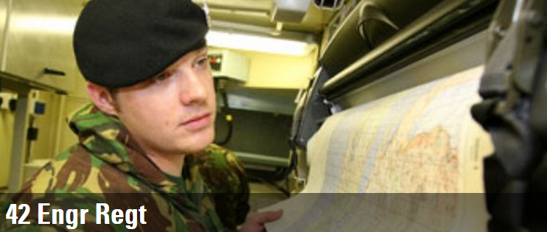

Based at Denison Barracks in Hermitage, near Newbury, 42 Engineer Regiment (Geographic) is a Joint Force Command specialist Royal Engineer unit that provides geographic support to all elements of UK Defence; particularly to Army headquarters, formations and units.  
  
The Regiment consists of the following units:  
  
• 13 Geographic Squadron  
• 14 Geographic Squadron  
• 16 Geographic Support Squadron  
  
• 135 Independent Geographic Squadron RE routinely reinforces the Regiment with Reservists as 'individual augmentees'.  
  
**Capabilities**  
The role of 42 Engineer Regiment (Geographic) is to provide field deployable geographic support to Defence. As well as supporting Current Operations, it maintains sub-units and individuals at readiness for deployment and support to exercises.  
  
The capabilities provided by the Regiment range from raw data collection (including geodetic surveys) and information management; through information exploitation, terrain analysis and visualisation; to geospatial information dissemination (electronically across networks, by bulk reproduction and supply of hard copy mapping, or on a digital media).  
  
**Deployments**The Regiment’s current main effort is support to Op HERRICK in Afghanistan; providing additional specialist officers and soldiers to augment and reinforce existing embedded geographic personnel on the deployed staffs. The current requirement for geographic support in Afghanistan has led to a dispersed Geographic Support Group (GSG) of about a half-Squadron size being deployed from the Regiment on an enduring basis there.  
  
In addition to Afghanistan the Regiment plays a key part in other Defence outputs. These tasks have recently included deployments of airfield survey teams around the world to contribute to international air safety as part of the Terminal Aeronautical GNSS Geodetic Survey (TAGGS) Programme; support to other Defence Intelligence organisations; support to other Intelligence Agencies; and finally support to the Op ELLAMY Libya campaign where Regimental personnel worked both in the Foreign and Commonwealth Office, and at sea with the UK Naval Task Group.  
  
Closer to home, the Regiment continues to be heavily involved in support to UK Operations through the Standing Joint Command.

**Sport, Adventure Training and other Opportunities**The Regiment has an excellent sporting ethos and record of success. Teams regularly compete in a variety of cricket, rugby, football, boxing, golf, cross country, swimming and volleyball competitions. Members of the Regiment have and do currently represent the Combined Services and Army at rugby, cricket and swimming. Of particular note this year, the Regiment has won the Army Minor Unit Cups for hockey, squash and athletics.  
  
A contingent from the Regiment spent the beginning of March 2012 on the annual Regimental Winter Ski-Touring Exercise in Les Contamines, France. The Regiment also saw its football team head to Boston, Massachusetts in the summer of 2011 to compete against three local collegiate teams. In addition, members of the Regimental Cycling Team went to the French Alps to complete the 760 km ride from Thon-les-Bains on the shores of Lake Geneva to Antibes on the Cote D’Azur in July 2011. Closer to home, adventurous training activities have recently been conducted by Squadrons in the Lake District, Brecon Beacons and Bavaria.

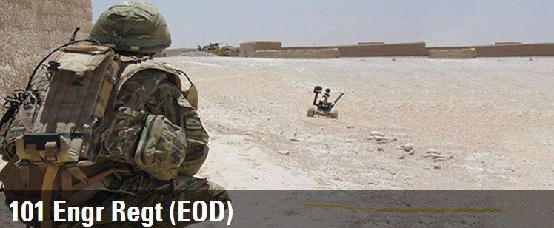

A SHORT HISTORY OF 101 (CITY OF LONDON) ENGINEER REGIMENT (EXPLOSIVE ORDNANCE DISPOSAL)  
  
101 (City of London) Engineer Regiment (Explosive Ordnance Disposal) – the Black Cats - formed in 1860 in Knightsbridge. The unit has been at the vanguard of the ‘integrated’ (including both regular and reserve squadrons) Army since 2010.

The Regiment has a strong operational pedigree, having provided Royal Engineer Bomb Disposal teams to neutralize the threat of German bombs during World War II, whilst more recently the Regiment has routinely supported operations in Afghanistan, dealing with the pernicious improvised explosive device (IED).

One of two specialist and deployable Royal Engineer bomb disposal regiments responsible for providing mobility support to the Army’s armoured infantry brigades, we also undertake a wide range of capacity building and training missions around the globe. Core capabilities include: High assurance search, bomb disposal and explosive ordnance clearance and dive trained personnel.

The Regimental emblem is taken from the 56th London Division flash worn during World War II and represents ‘Tommy’, Dick Whittington’s cat. Predominantly based at Carver Barracks, near Saffron Walden the Regiment’s Reserve component has detachments in Catford, Rochester, Tunbridge Wells and Reigate. The Regiment includes the following sub-units:

• 22 HQ & Sp Sqn (EOD)  
• 17 Fd Sqn (EOD)  
• 21 Fd Sqn (EOD)  
• 221 Fd Sqn (EOD)  
• 579 Fd Sqn (EOD)  
  
**22 Headquarter and Support Squadron (Explosive Ordnance Disposal)**

Formed in Halifax on 2 October 1940, the Squadron was based in Chelmsford before a re-organization of bomb disposal companies saw them focussed on East Anglia and the South Midlands. After the War the Squadron continued to clear WW2 ordnance, which included significant finds at the Beckton Gas works, East London (1986), a 1000kg bomb in Bermondsey (1987) and Isle of Dogs (1988). On 1 April 2000 the Squadron was renamed to adopt the title of today, whilst operational experience has included the Falkland Islands, Bosnia Herzegovina, Kosovo, Afghanistan, Iraq and the 2012 Olympic Games.

Its current operational role is to support the United Kingdom’s Technical Response Force, with a team held at 3 hours notice to move to respond to a nuclear or radiological incident anywhere in the United Kingdom.  
  
**17 Field Squadron (Explosive Ordnance Disposal)**

Formed on 2 October 1940 in Halifax, the Squadron was based in Sevenoaks, Kent until November 1942, when they joined the Allied Task force on Operation TORCH, the invasion of North Africa. This was followed by a move to Italy, as part of Operation HUSKY (July 1943), the Company dealt with over 1,000 unexploded bombs, defused and removed approximately 4,500 bombs from dumps and cemeteries, neutralised in excess of 300 mines and gathered intelligence on numerous, previously unseen items.

At the end of the war No. 17 Bomb Disposal Company was disbanded. 17 Field Squadron (Explosive Ordnance Disposal) was reformed on 6 July 2006 and has subsequently seen operational service in Afghanistan and Northern Ireland.  
  
**21 Field Squadron (Explosive Ordnance Disposal)**

21 Bomb Disposal (BD) Company was formed in Halifax on 2 Oct 1940, in response to the German bombing of London. With the Blitz at its most ferocious, the company deployed to South Woodford, London in January 1941, with an operational area of the North-East quadrant of the City of London, remaining in London until large-scale German raids had ceased.

Disbanded in early 1946, 21 Field Squadron (Explosive Ordnance Disposal) was reformed in 1990 for Operation GRANBY, the liberation of Kuwait. Since its reformation the Squadron has supported operations in the Balkans, Iraq and Afghanistan.  
  
**221 Field Squadron (Explosive Ordnance Disposal)**

Formed in 1920, on the reconstitution of the Territorial Army (now the Army Reserve), 221 Squadron was mobilized alongside the 56th Division to support the British Expeditionary Force in France. Subsequently it saw service in Persia, Iraq, North Africa, Sicily and Italy, suffering heavy casualties during the Salerno landings. With the exception of periods of Regimental suspended animation, 221 Squadron has remained with 101st throughout its existence.  
  
**579 Field Squadron (Explosive Ordnance Disposal)**

Originating from World War 1, 579 Squadron are the direct descendants of No. 6 Company Kent Fortress Royal Engineers (1915). Disbanded after the War, they were reformed in 1939, before deploying alongside 1st Army to North Africa on Operation TORCH in 1943, finishing the War in Italy. Reorganized to become a bomb disposal Squadron in 1950, the Squadron returned to its spiritual home in Rochester, before being disbanded in 1961. The Reserve Squadron reformed in 1990 in its current role.  
  
**Summary**

The Regiment has retained an unbroken link with the London Divisions over nearly 60 years, which included both World Wars. Furthermore, elements of the Regiment have been actively involved in securing the City of London from the threat of unexploded ordnance since the Blitz, which included direct support to Operation OLYMPICS; the longest and largest military security operation on mainland United Kingdom since World War II.

In April 2000 the then Lord Mayor of the City of London, Alderman Clive Martin, granted “City of London” status to the Regiment in recognition of its long and distinguished association with the Corporation; the Regiment retains close affiliations even today with the Curriers, Patternmakers, Fan Makers, Lightmongers and Constructors. In its 150 year history the Regiment has undergone no less than thirteen changes of name, however, ‘London’ has been the one constant for the past 102 years.

If you would like anymore information about joining the Reserves please contact Capt Stuart Bailey on 0208 697 9250 or 07824519070. You can also find out more by liking our Facebook page or following us on Twitter @101EngrRegt.

**20 Works Group RE (Air Support)**

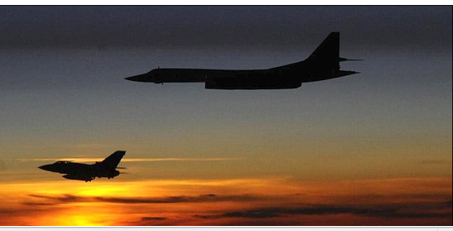

The 20 Works Group Royal Engineers (Air Support) sits within 12 (Force Support) Engineer Group and delivers specialist infrastructure engineering to the Air, Land, Logistic, Maritime and Special Forces Components within the Land environment in order to support theatre entry, sustained operations and recovery.

The Works Group primary focus is the delivery of Infrastructure Support to the RAF both in the UK and on operational deployments. The Works Group is made up of five Specialist Teams Royal Engineers (STREs). Four of these teams sit on RAF Main Operating Bases in the East of the country. They are at readiness to deploy and provide resilience to the fifth Very High Readiness Team. On a day to day basis they gain valuable infrastructure experience whilst working with the RAF. Their remit is to ensure that the infrastructure on their Main Operating Base is maintained to support the operational missions of the various air stations, such as the Quick Reaction Force which protects the UK air space from unauthorised entry.

The group’s 5th STRE is located at RAF Wittering and is permanently on a heightened state of Readiness in order to deploy anywhere in the world at very short notice. Its role is to activate and enable Deployed Operating Bases for Air and Aviation operations.

**As infrastructure specialists we delivery the following key capabilities:**

* Design Consultancy
* Programme and Project Management
* Contract Management
* Facilities Management
* Specialist Maintenance (Power, Fuel, Heating and Refrigeration)

In relation to supporting the Air and Aviation Component on operations we look to plan, assess, design and procure expeditionary solutions to the ‘big 6’ infrastructure components of an airfield. The ‘Big 6’ comprise of :

* Air Operating Surfaces
* Fuel Storage
* Ammunition Storage
* Technical Accommodation
* Domestic Accommodation
* Force Protection